**SATELLITE COMMUNICATION**

**MINI-PROJECT REPORT**

**ORBITAL MECHANICS SIMULATION USING SYSTEMS TOOL KIT**

**SUBMITTED BY**

**RAGUVARAN R (513121106074)**

**RAJESHKUMAR V(513121106075)**

**PUGAZHMANI P (513121106072)**



**DEPARTMENT OF ELECTRONICS AND COMMUNICATION ENGINEERING**

**THANTHAI PERIYAR GOVERNMENT INSTITUTE OF TECHNOLOGY**

**VELLORE-2**

**TABLE OF CONTENT PG.NO**

**ABSTRACT…………………………………………………………………………………..(3)**

**CHAPTER 1:ORBITAL ELEMENTS ANALYSIS…………………………………..(4)**

**CHAPTER 2:TRAJECTORY DESIGN USING ASTROGATOR………………..(7)**

**CHAPTER 3:INCLINATION CHANGE USING ASTROGATOR……………(10)**

**CHAPTER 4:DESIGN OF HOHMANN TRANSFER ORBIT………………..(13)**

**CHAPTER 5:MOON MISSION USING B PLANE TARGETING………….(16)**

**CONCLUSION…………………………………………………………………….………(19)**

**Abstract:**

The project titled "Orbital Mechanics Simulation" represents a comprehensive exploration into the intricate dynamics of spacecraft trajectories and orbits, facilitated by the cutting-edge Systems Tool Kit (STK) software. Over the course of several meticulously crafted chapters, this endeavor delves deeply into the multifaceted process of designing, optimizing, and analyzing trajectories tailored for a diverse array of missions, with a focal point on the challenging domain of moon exploration.

Harnessing the advanced capabilities of STK, the project navigates through the complexities of scenario setups, Astrogator simulations, and convergence analyses, unraveling the nuanced interplay of forces and parameters that govern the trajectory of spacecraft. From the elegant simplicity of Hohmann transfers to the meticulous precision of B-plane approaches, each chapter offers invaluable insights into the art and science of mission planning and execution within the vast expanse of orbital mechanics.

Beyond mere exploration, this project serves as a testament to the indispensable role of simulation software in advancing our understanding and capabilities in the realm of space exploration. By elucidating the intricacies of orbital mechanics and showcasing the versatility of STK, it lays a solid foundation for future endeavors, inspiring further innovation and discovery in the boundless frontier of outer space. Through this ambitious endeavor, we embark on a journey of exploration, discovery, and enlightenment, driven by the relentless pursuit of knowledge and the insatiable curiosity that propels humanity ever closer to the stars.

**CHAPTER 1:ORBITAL ELEMENTS ANALYSIS:**

**Introduction:**

This simulation workflow outlines the process of inserting a satellite, defining its orbital elements, simulating its trajectory, and visualizing the orbital parameters through graphs. It concludes with the generation of a comprehensive report summarizing the simulation results, aiding in the analysis of satellite communications systems.

Here are the steps outlined concisely:

1. **Insert Satellite Using Default Method**
   * Utilize the default method to insert a satellite into the simulation environment.
2. **Define Orbital Elements**
   * Define the orbital parameters for the inserted satellite, including semi-major axis, eccentricity, inclination, etc.

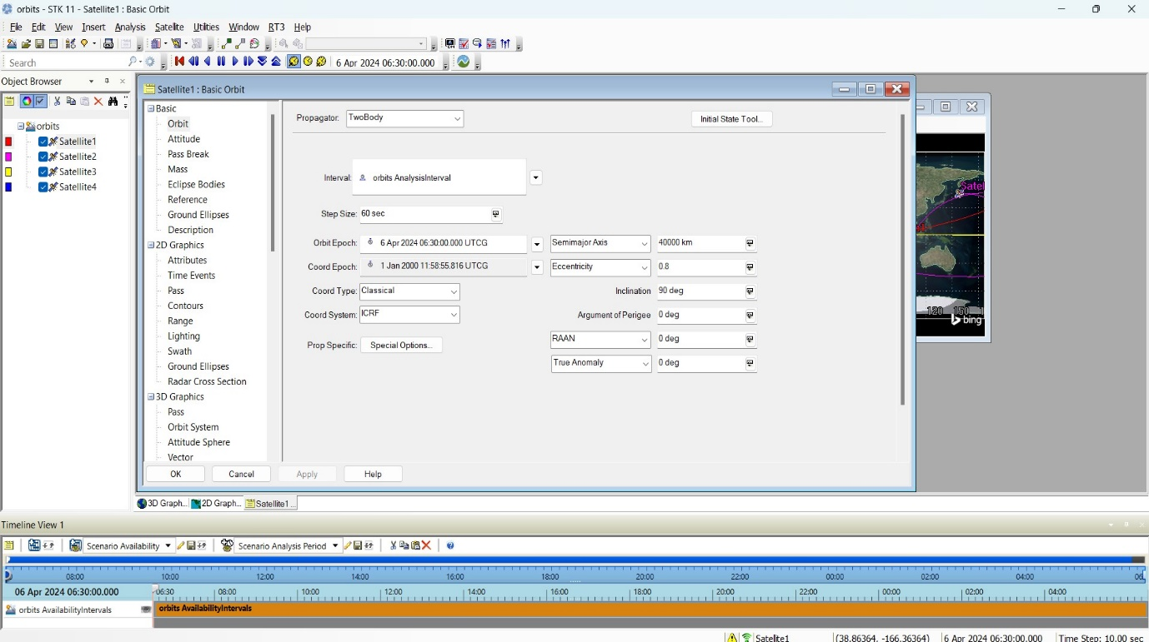

**3.Simulate**

* Initiate the simulation to model the satellite's orbit based on the defined orbital elements.

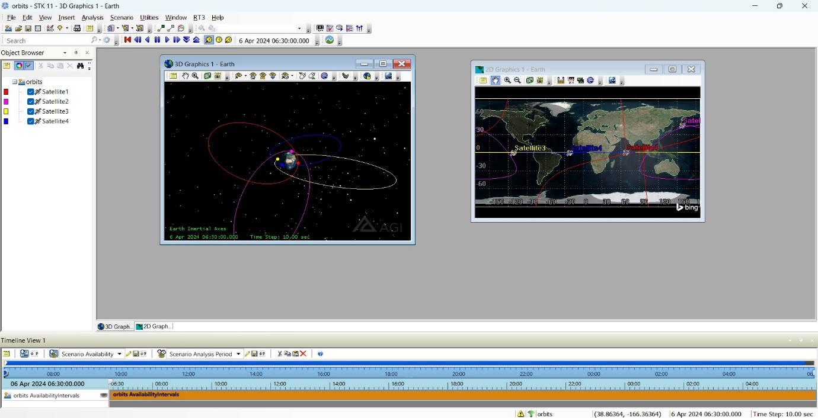

**4.Obtain Report Using Reports Manager**

* Utilize the reports manager to generate a comprehensive report summarizing the simulation results.
* The report should include analysis of orbital elements, insights gained, and implications for satellite communications.

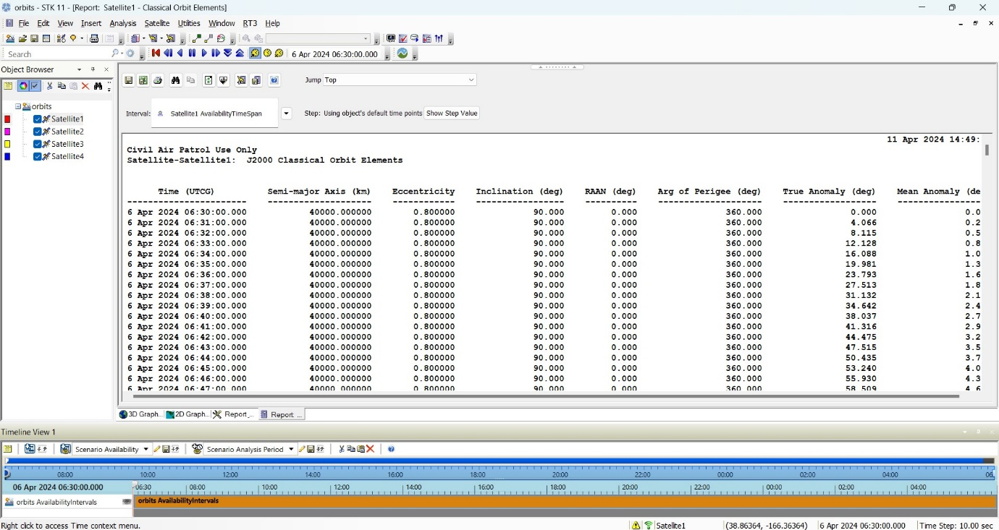

**5.Obtain Plot of Orbital Elements Using Graphs Manager**

* Utilize the graphs manager to generate plots depicting the variation of orbital elements over time.
* Graphs should include semi-major axis, eccentricity, inclination, and other relevant parameters.

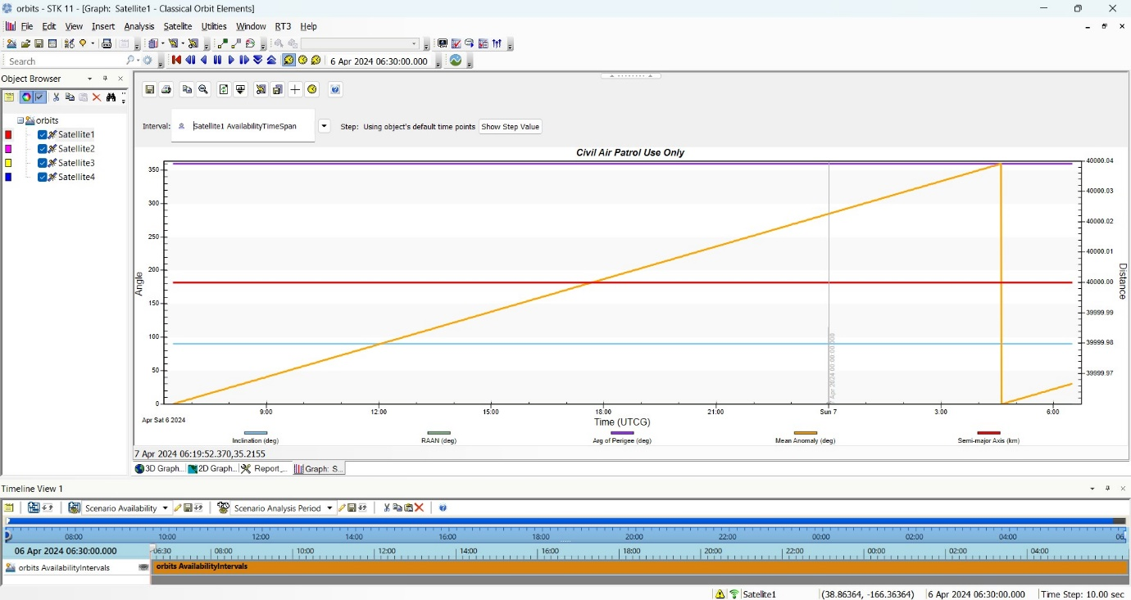

**CHAPTER 2:TRAJECTORY DESIGN USING ASTROGATOR**:

**Introduction:**

This trajectory design scenario using Astrogator in STK aims to efficiently plan and execute spacecraft trajectories, from launch to achieving a geosynchronous equatorial orbit (GEO). By leveraging Astrogator's capabilities, engineers can optimize mission planning and operations for satellite deployments with high-fidelity trajectory designs.

Here are the steps outlined concisely:

**1.Trajectory Design Using Astrogator**

* Introduction to Astrogator for spacecraft trajectory design in STK.
* Steps involved in defining and optimizing trajectories for satellite missions.

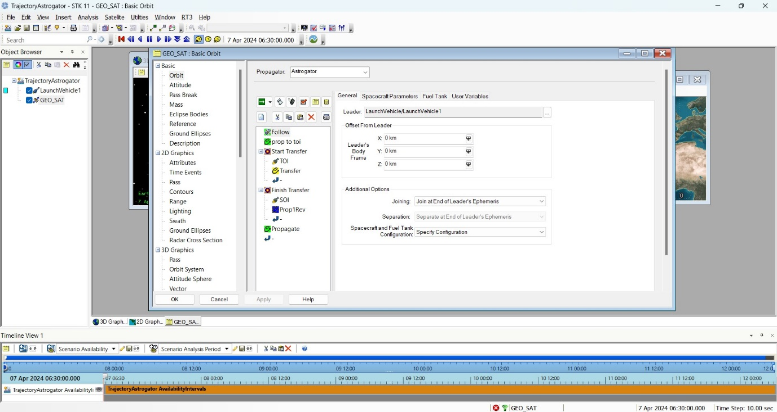

**2.Satellite Tracking and Analysis within the Trajectory**

* Tracking and analyzing satellite movement within the planned trajectory.
* Utilizing Astrogator to assess satellite position, velocity, and orbital dynamics throughout the mission, with a focus on convergence-related metrics for trajectory refinement.

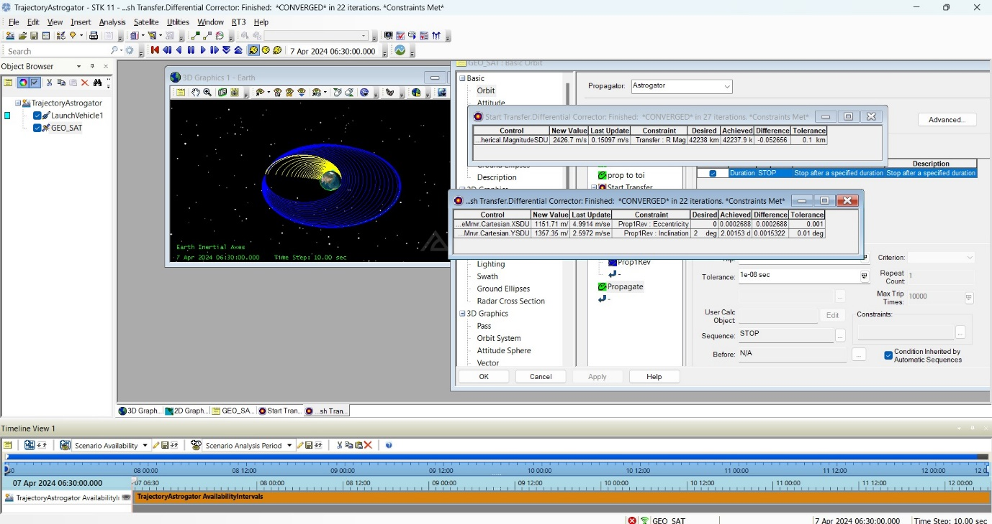

**3.Trajectory Simulation and Analysis**

* Simulation of spacecraft trajectories using Astrogator in STK.
* Analysis of trajectory performance, including accuracy, fuel consumption, and mission objectives, with an emphasis on monitoring convergence during simulation.

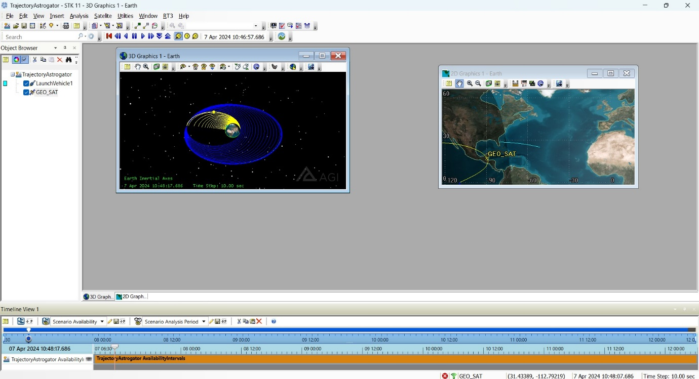

**4.Generating Mission Summary Reports**

* Generating comprehensive mission summary reports using Astrogator in STK.
* Overview of key metrics and performance indicators included in the mission summary reports, reflecting convergence status and trajectory optimization results.

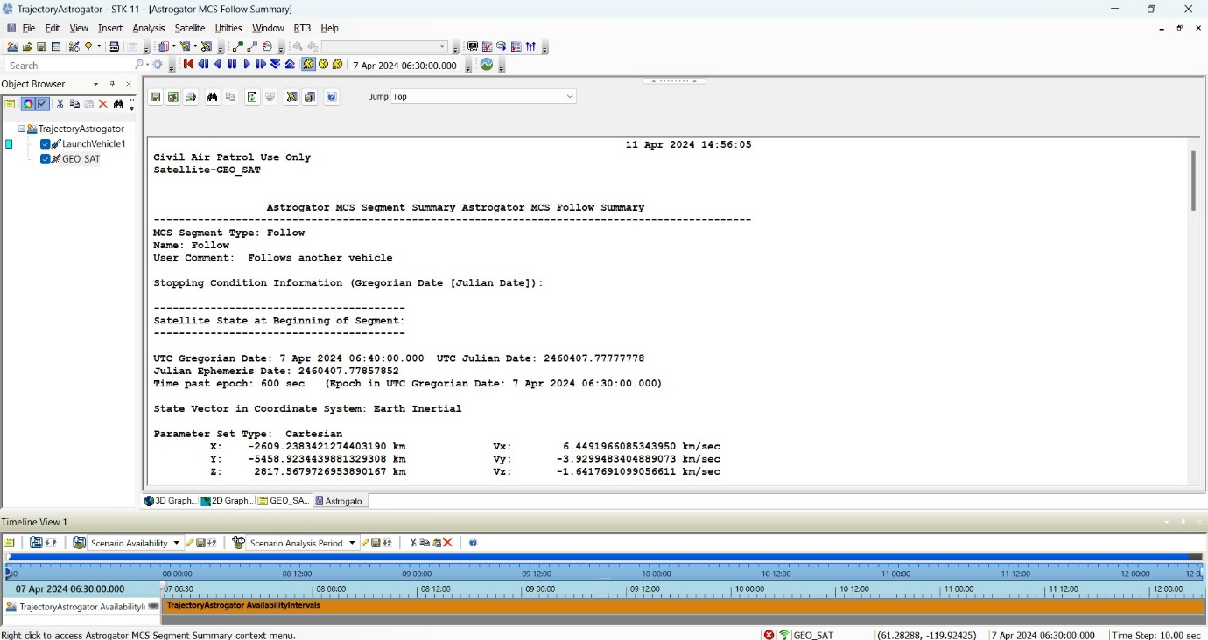

**5.Satellite Movement Along the Trajectory**

* Understanding how satellites traverse their designated trajectories.
* Examining the factors influencing satellite movement, such as gravitational forces, orbital perturbations, and maneuver executions, throughout the mission duration.

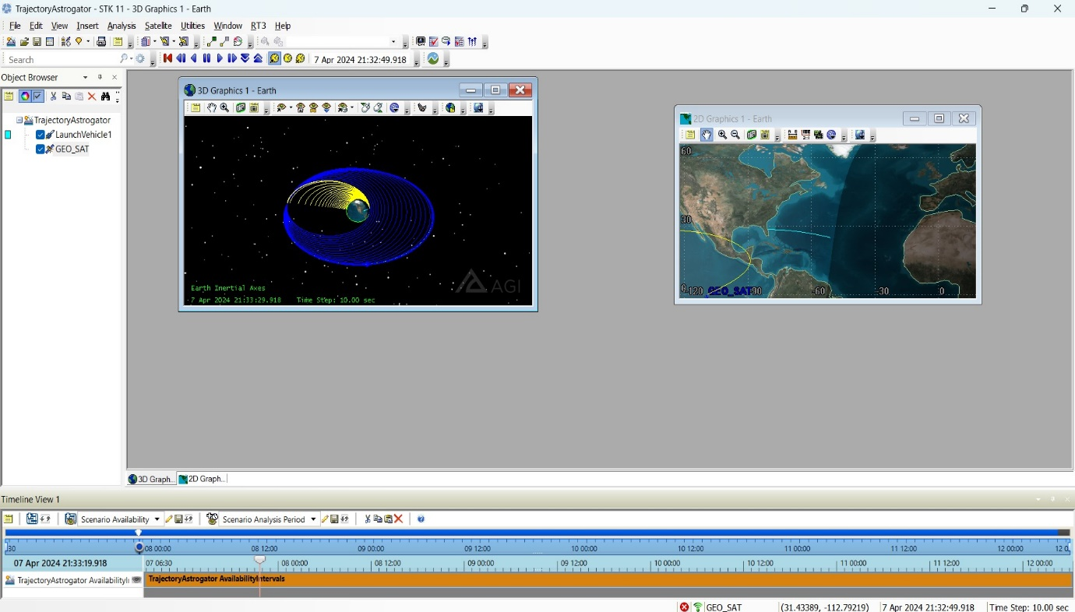

**CHAPTER 3:INCLINATION CHANGE USING ASTROGATOR:**

**Introduction:**

This chapter explores the utilization of Astrogator in STK to execute an inclination change maneuver within a Hohmann transfer scenario. The process involves defining a Hohmann transfer with three orbits, ensuring convergence of the trajectory, generating a mission summary, simulating and analyzing the trajectory, and examining the inclination change during the final orbit.

Here are the steps outlined concisely:

**1.Trajectory Design Using Astrogator**

* Introduction to Astrogator for planning spacecraft trajectories in STK.
* Steps involved in defining a Hohmann transfer with three orbits, incorporating Astrogator's capabilities for trajectory optimization.

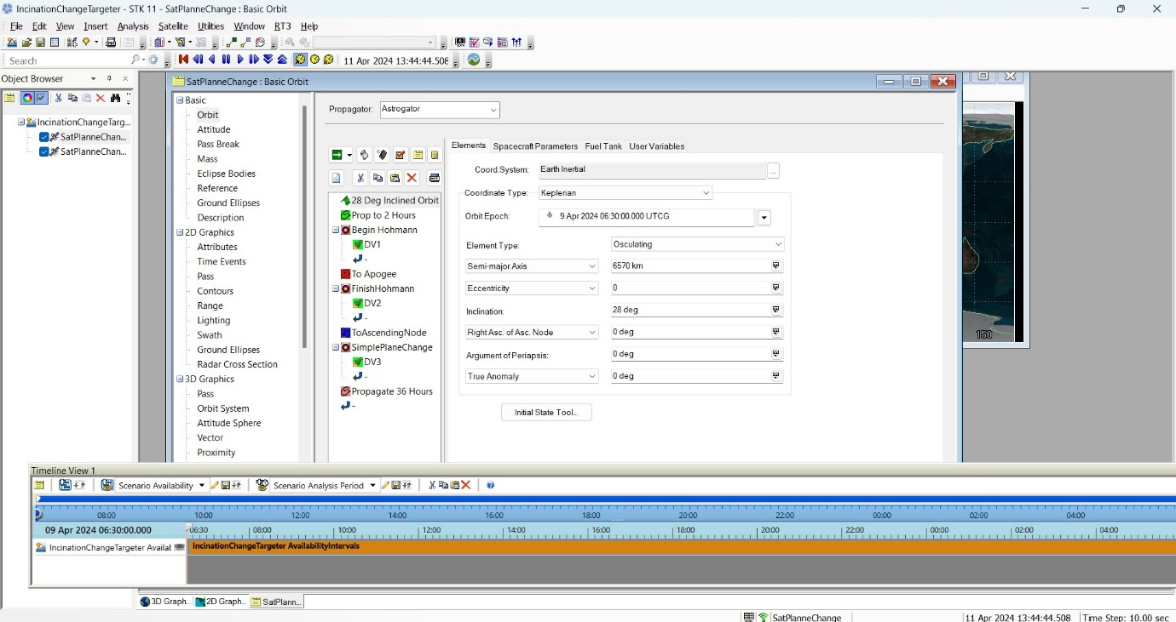

**2.Convergence of Trajectory**

* Techniques for ensuring convergence of the Astrogator's differential corrector within the Hohmann transfer scenario.
* Monitoring convergence status and adjusting trajectory parameters as necessary for optimal results.

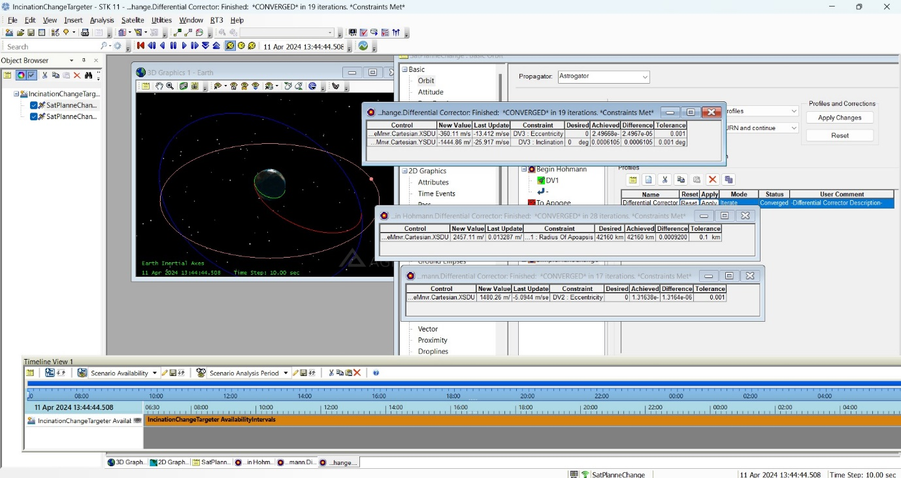

**3.Simulation and Analysis**

* Simulating the Hohmann transfer trajectory using Astrogator in STK.
* Analysis of trajectory performance, including accuracy, fuel consumption, and mission objectives, with an emphasis on convergence-related metrics.

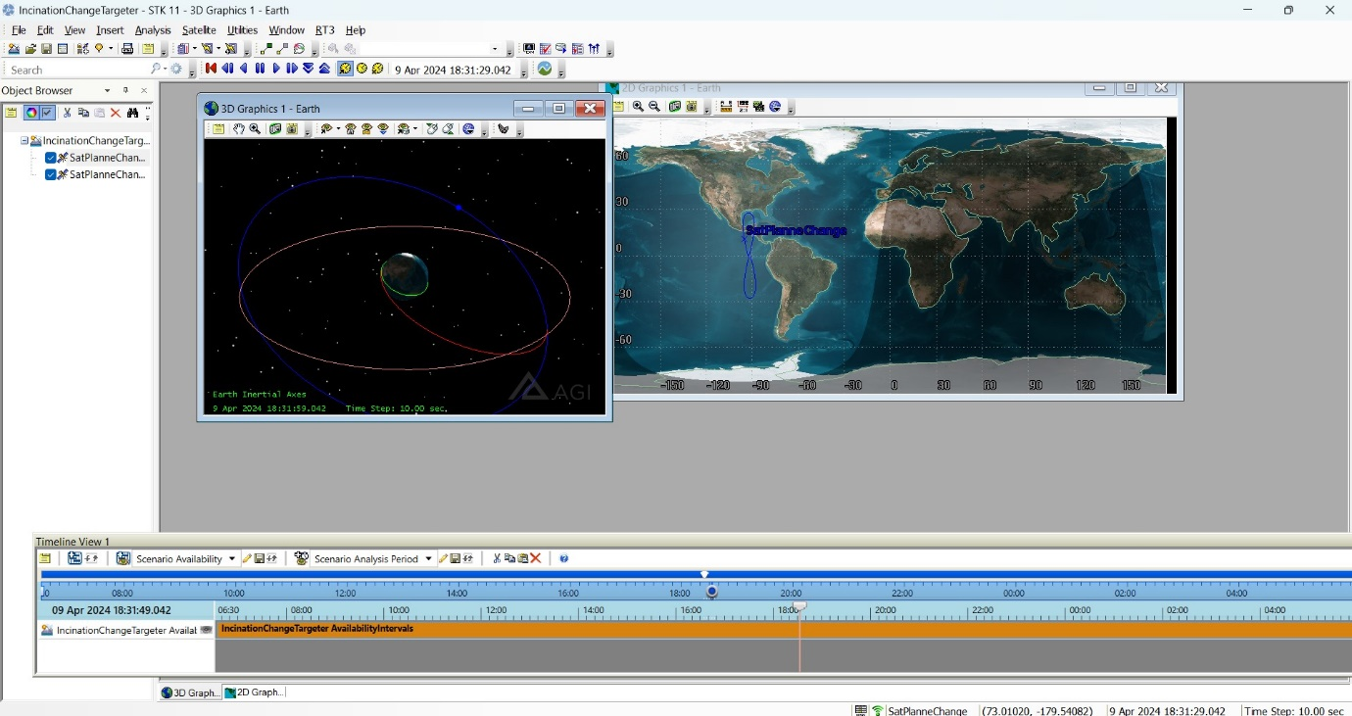

**4.Mission Summary Generation**

* Generating a comprehensive mission summary report to evaluate the Hohmann transfer trajectory.
* Overview of key metrics and performance indicators included in the mission summary, reflecting convergence status and trajectory optimization.

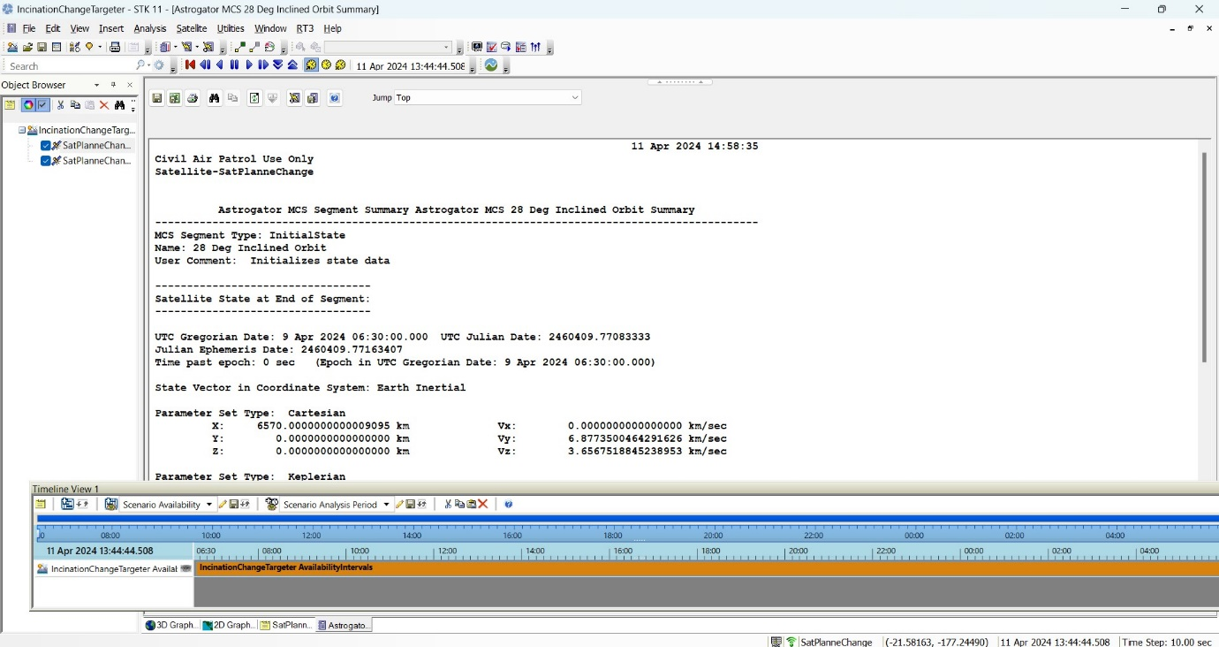

**5.Inclination Change During Final Orbit**

* Examination of the inclination change executed by the satellite during the final orbit of the Hohmann transfer.
* Analysis of the factors influencing the inclination change and its implications for mission planning and operations.

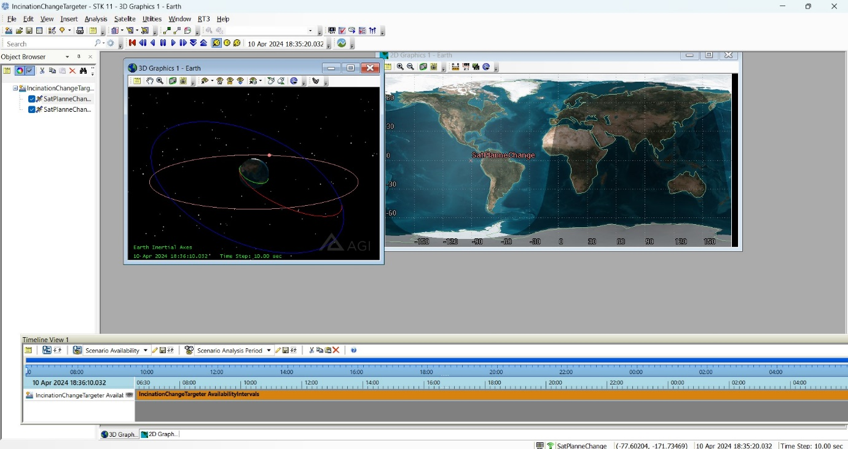

**CHAPTER 4:DESIGN OF HOHMANN TRANSFER ORBIT:**

**Introduction:**

This chapter delves into the process of designing a Hohmann transfer orbit using Astrogator in STK. It outlines the steps involved in designing three orbits, including an inner transfer and outer orbit, utilizing Astrogator's capabilities. The chapter also covers simulation, summary generation, and the transfer of a satellite into the outer orbit.

Here are the steps outlined concisely:

**1.Orbit Design Steps with Astrogator**

* + Introduction to Hohmann transfer orbit design methodology using Astrogator in STK.
  + Step-by-step guide outlining the process of designing three orbits for a Hohmann transfer, incorporating Astrogator's tools and features.

**2.Designing Three Orbits**

* + Utilization of Astrogator to design an inner transfer orbit and outer orbit for the Hohmann transfer.
  + Implementation of Astrogator's capabilities for trajectory optimization and convergence in orbit design.

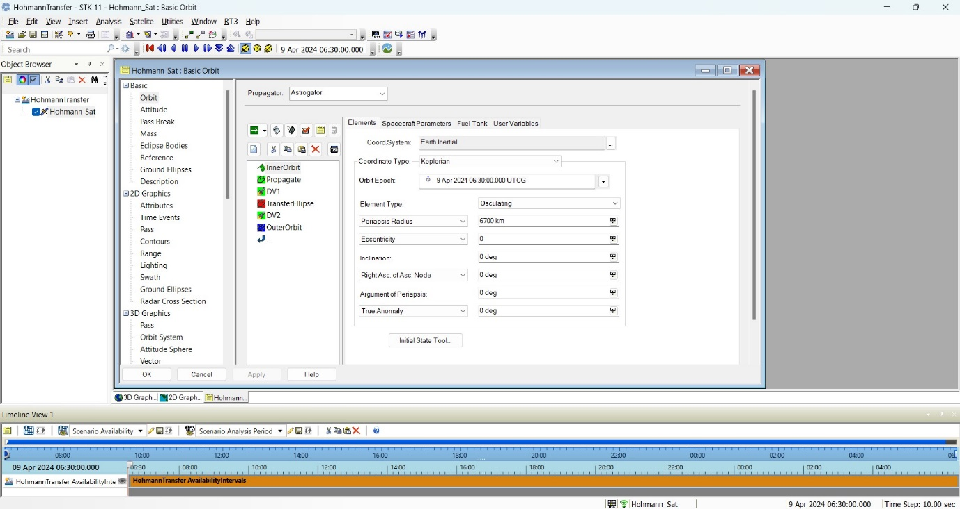

**3.Simulation of Hohmann Transfer**

* Simulation of the Hohmann transfer orbit design using Astrogator in STK.
* Analysis of trajectory dynamics and performance, including fuel consumption and transfer duration, through simulation.

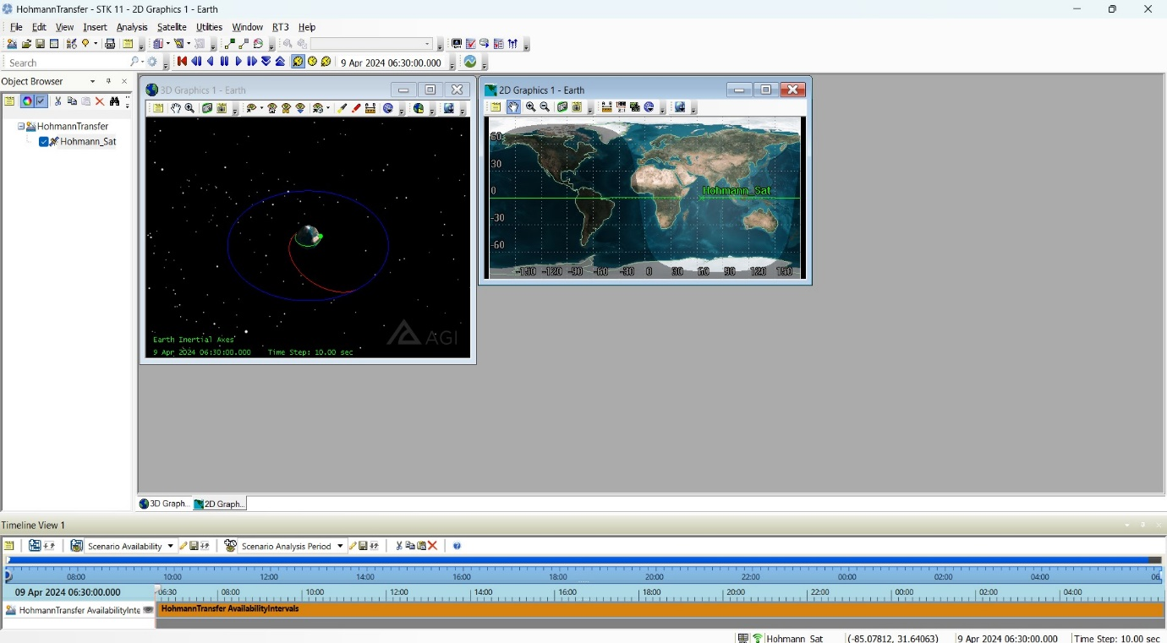

**4.Summary Generation**

* Generation of a comprehensive summary report to evaluate the Hohmann transfer orbit design.
* Overview of key metrics and performance indicators included in the mission summary, reflecting trajectory optimization and convergence status.

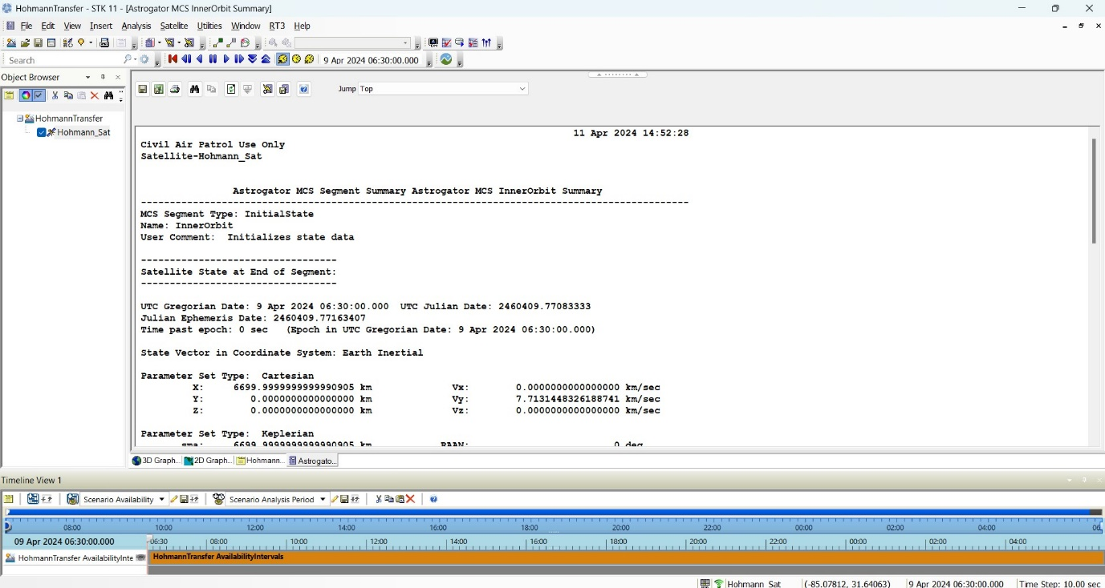

**5.Transfer of Satellite into Outer Orbit**

* Execution of the transfer of a satellite into the outer orbit of the Hohmann transfer.
* Analysis of satellite trajectory dynamics and implications for mission planning and operations within the outer orbit.

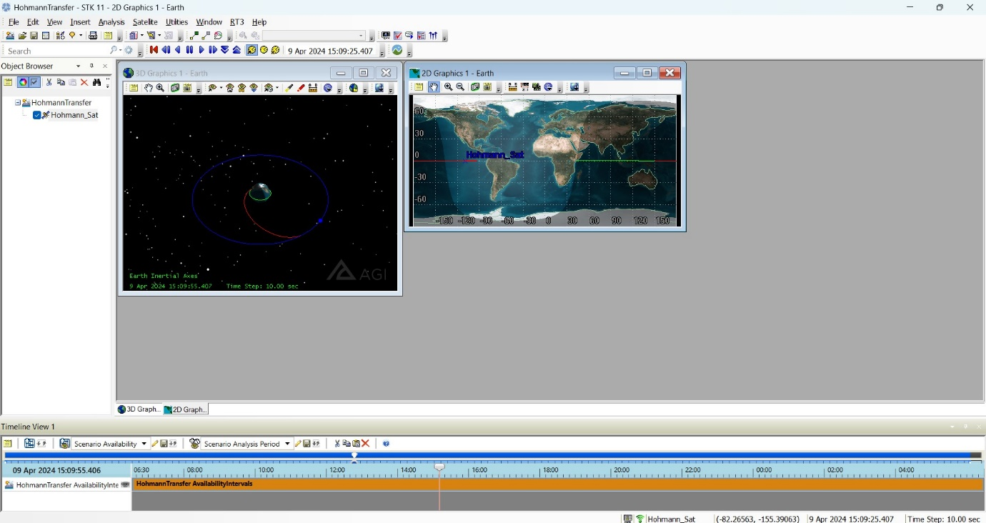

**CHAPTER 5:MOON MISSION USING BPLANE TARGETING:**

**Introduction:**

In this chapter, we embark on a journey through the intricacies of planning a moon mission using the B-plane method in STK. Through meticulous scenario setup, Astrogator simulation, and convergence analysis, we uncover the essential steps in designing and optimizing trajectories for lunar exploration.

Here are the steps outlined concisely:

**1.Scenario Setup**

* + Creation of a scenario with a stop time of +30 days.
  + Insertion of three different central bodies: moon, earth, and sun.

2.**Target Sequence Configuration**

* + Addition of a target sequence with launch, maneuver, and propagate segments.
  + Definition of stopping conditions and control variables for each segment.

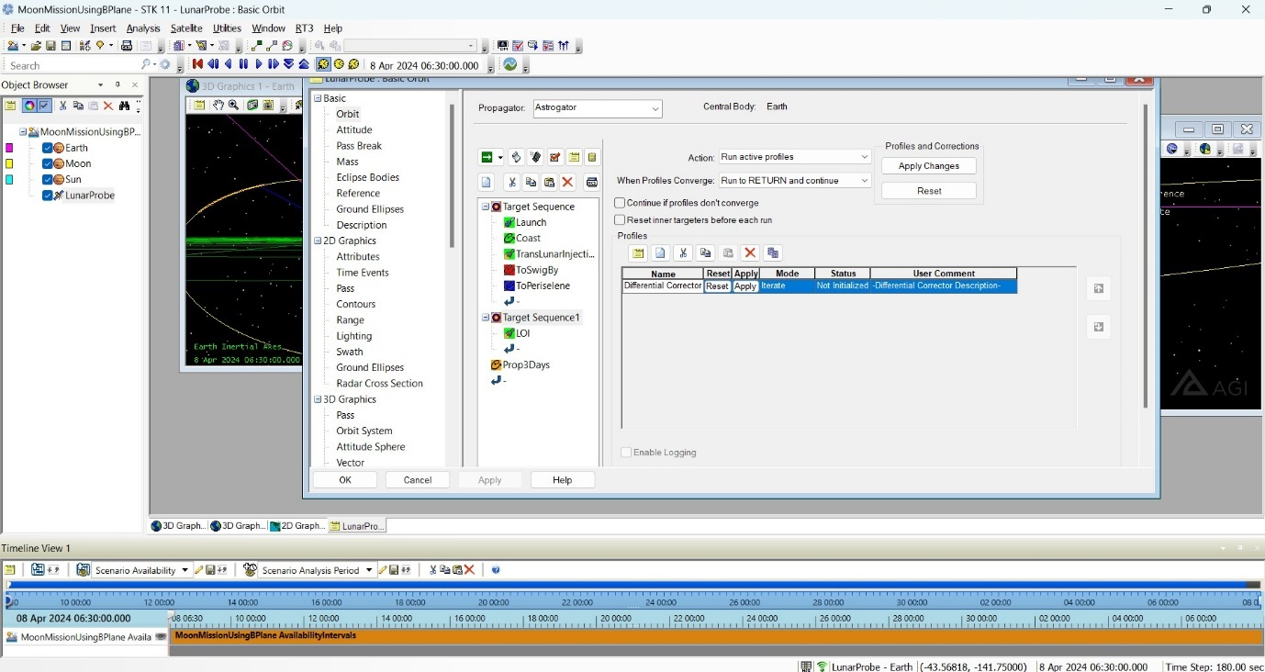

**2.Convergence Analysis**

* Monitoring and analysis of the Astrogator's differential corrector convergence for trajectory optimization.
* Adjustment of trajectory parameters to ensure convergence and optimal mission planning.

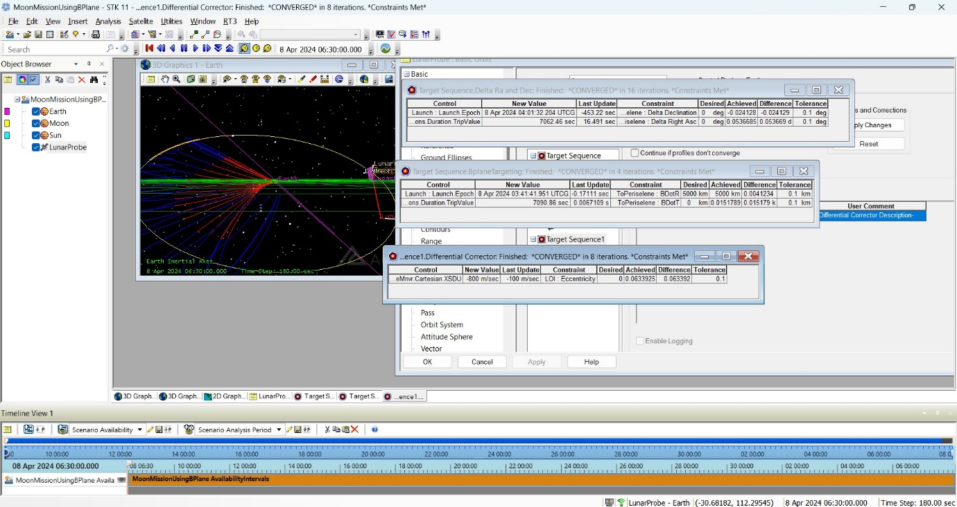

**4.B-Plane Settings**

* Creation of a B-plane for moon view visualization.
* Configuration of control variables such as delta right ascension and B-dot R/B-dot T targeting to avoid orbit intersection with the moon.

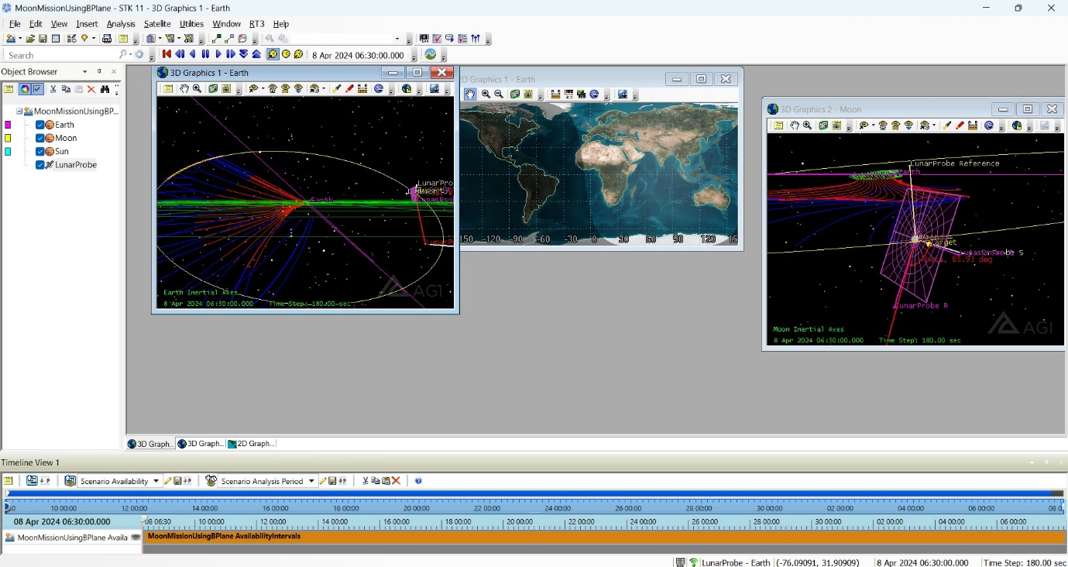

**5.Astrogator Simulation**

* Utilization of Astrogator for simulating the moon mission trajectory within the target sequence.
* Analysis of trajectory dynamics and performance, including fuel consumption and orbital characteristics, through simulation.

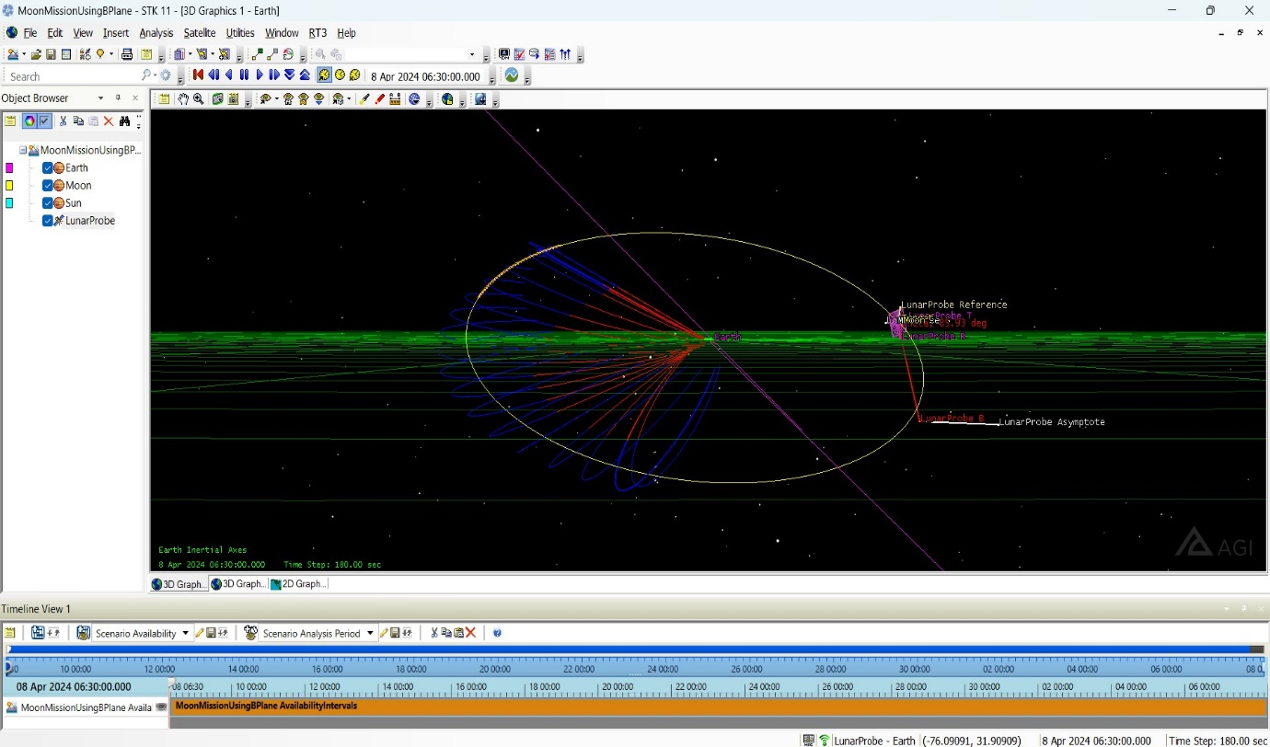

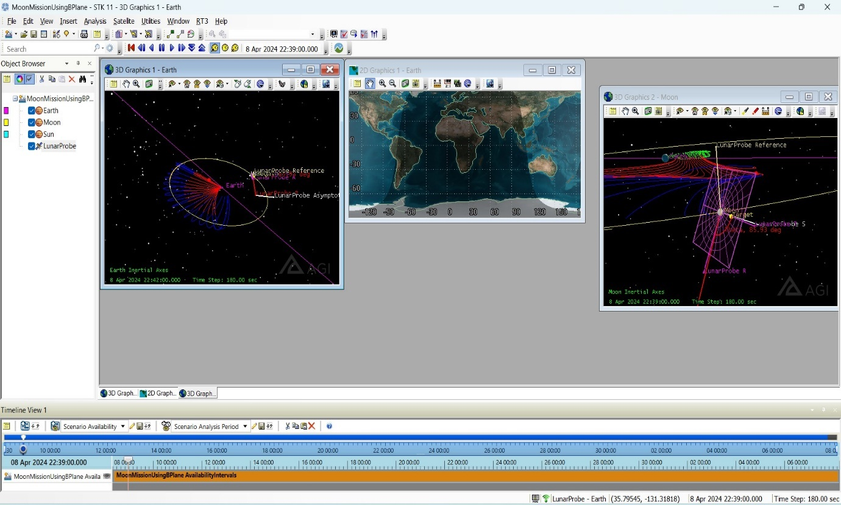

**Conclusion:**

Through the utilization of Systems Tool Kit (STK) software, this project has delved deep into the realm of orbital mechanics simulation, showcasing the intricacies of spacecraft trajectories and orbits.

From the meticulous setup of scenarios to the execution of Astrogator simulations and convergence analyses, each chapter has provided invaluable insights into the design and optimization of trajectories for various missions, including moon exploration.

By harnessing the capabilities of STK, we have navigated through the complexities of mission planning, execution, and analysis, highlighting the versatility and precision offered by modern simulation tools in the domain of space exploration.

As we conclude this journey, we recognize the significance of simulation software in advancing our understanding and capabilities in space exploration, paving the way for future endeavors and discoveries beyond the confines of our planet.